Calculation:

First two pages are calculation for lowpass filter

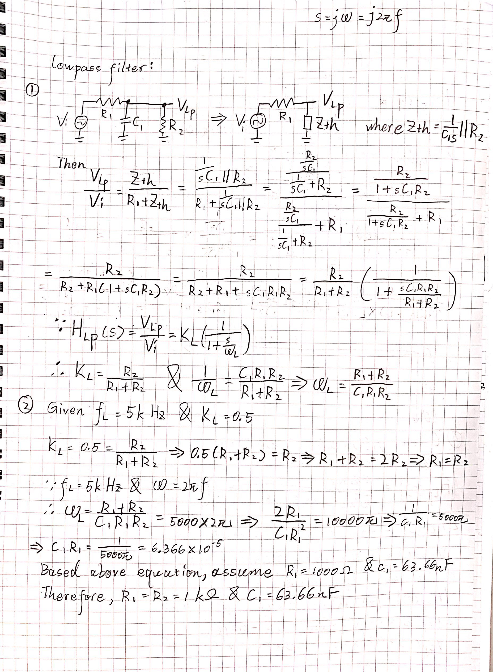

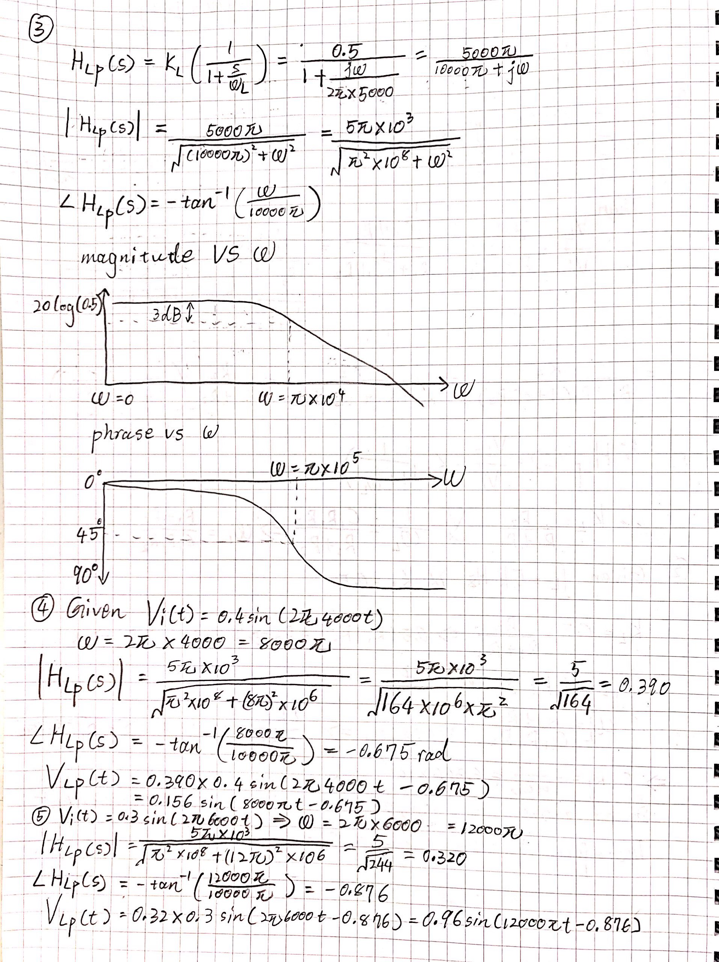

Highpass filter:

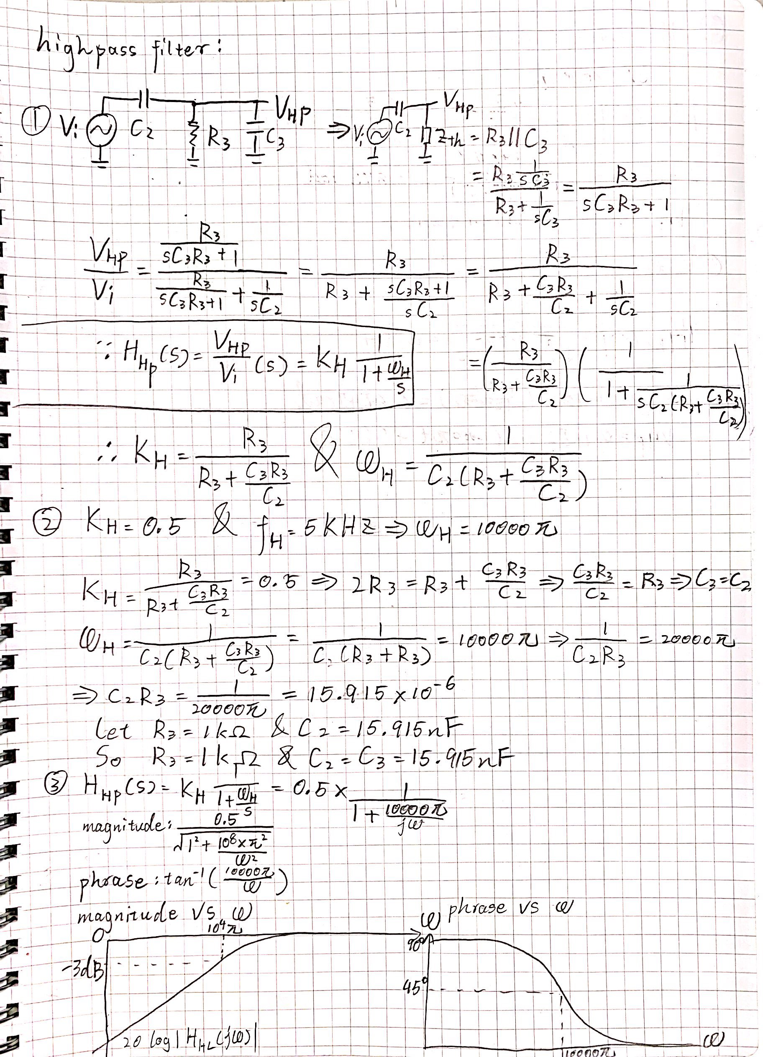

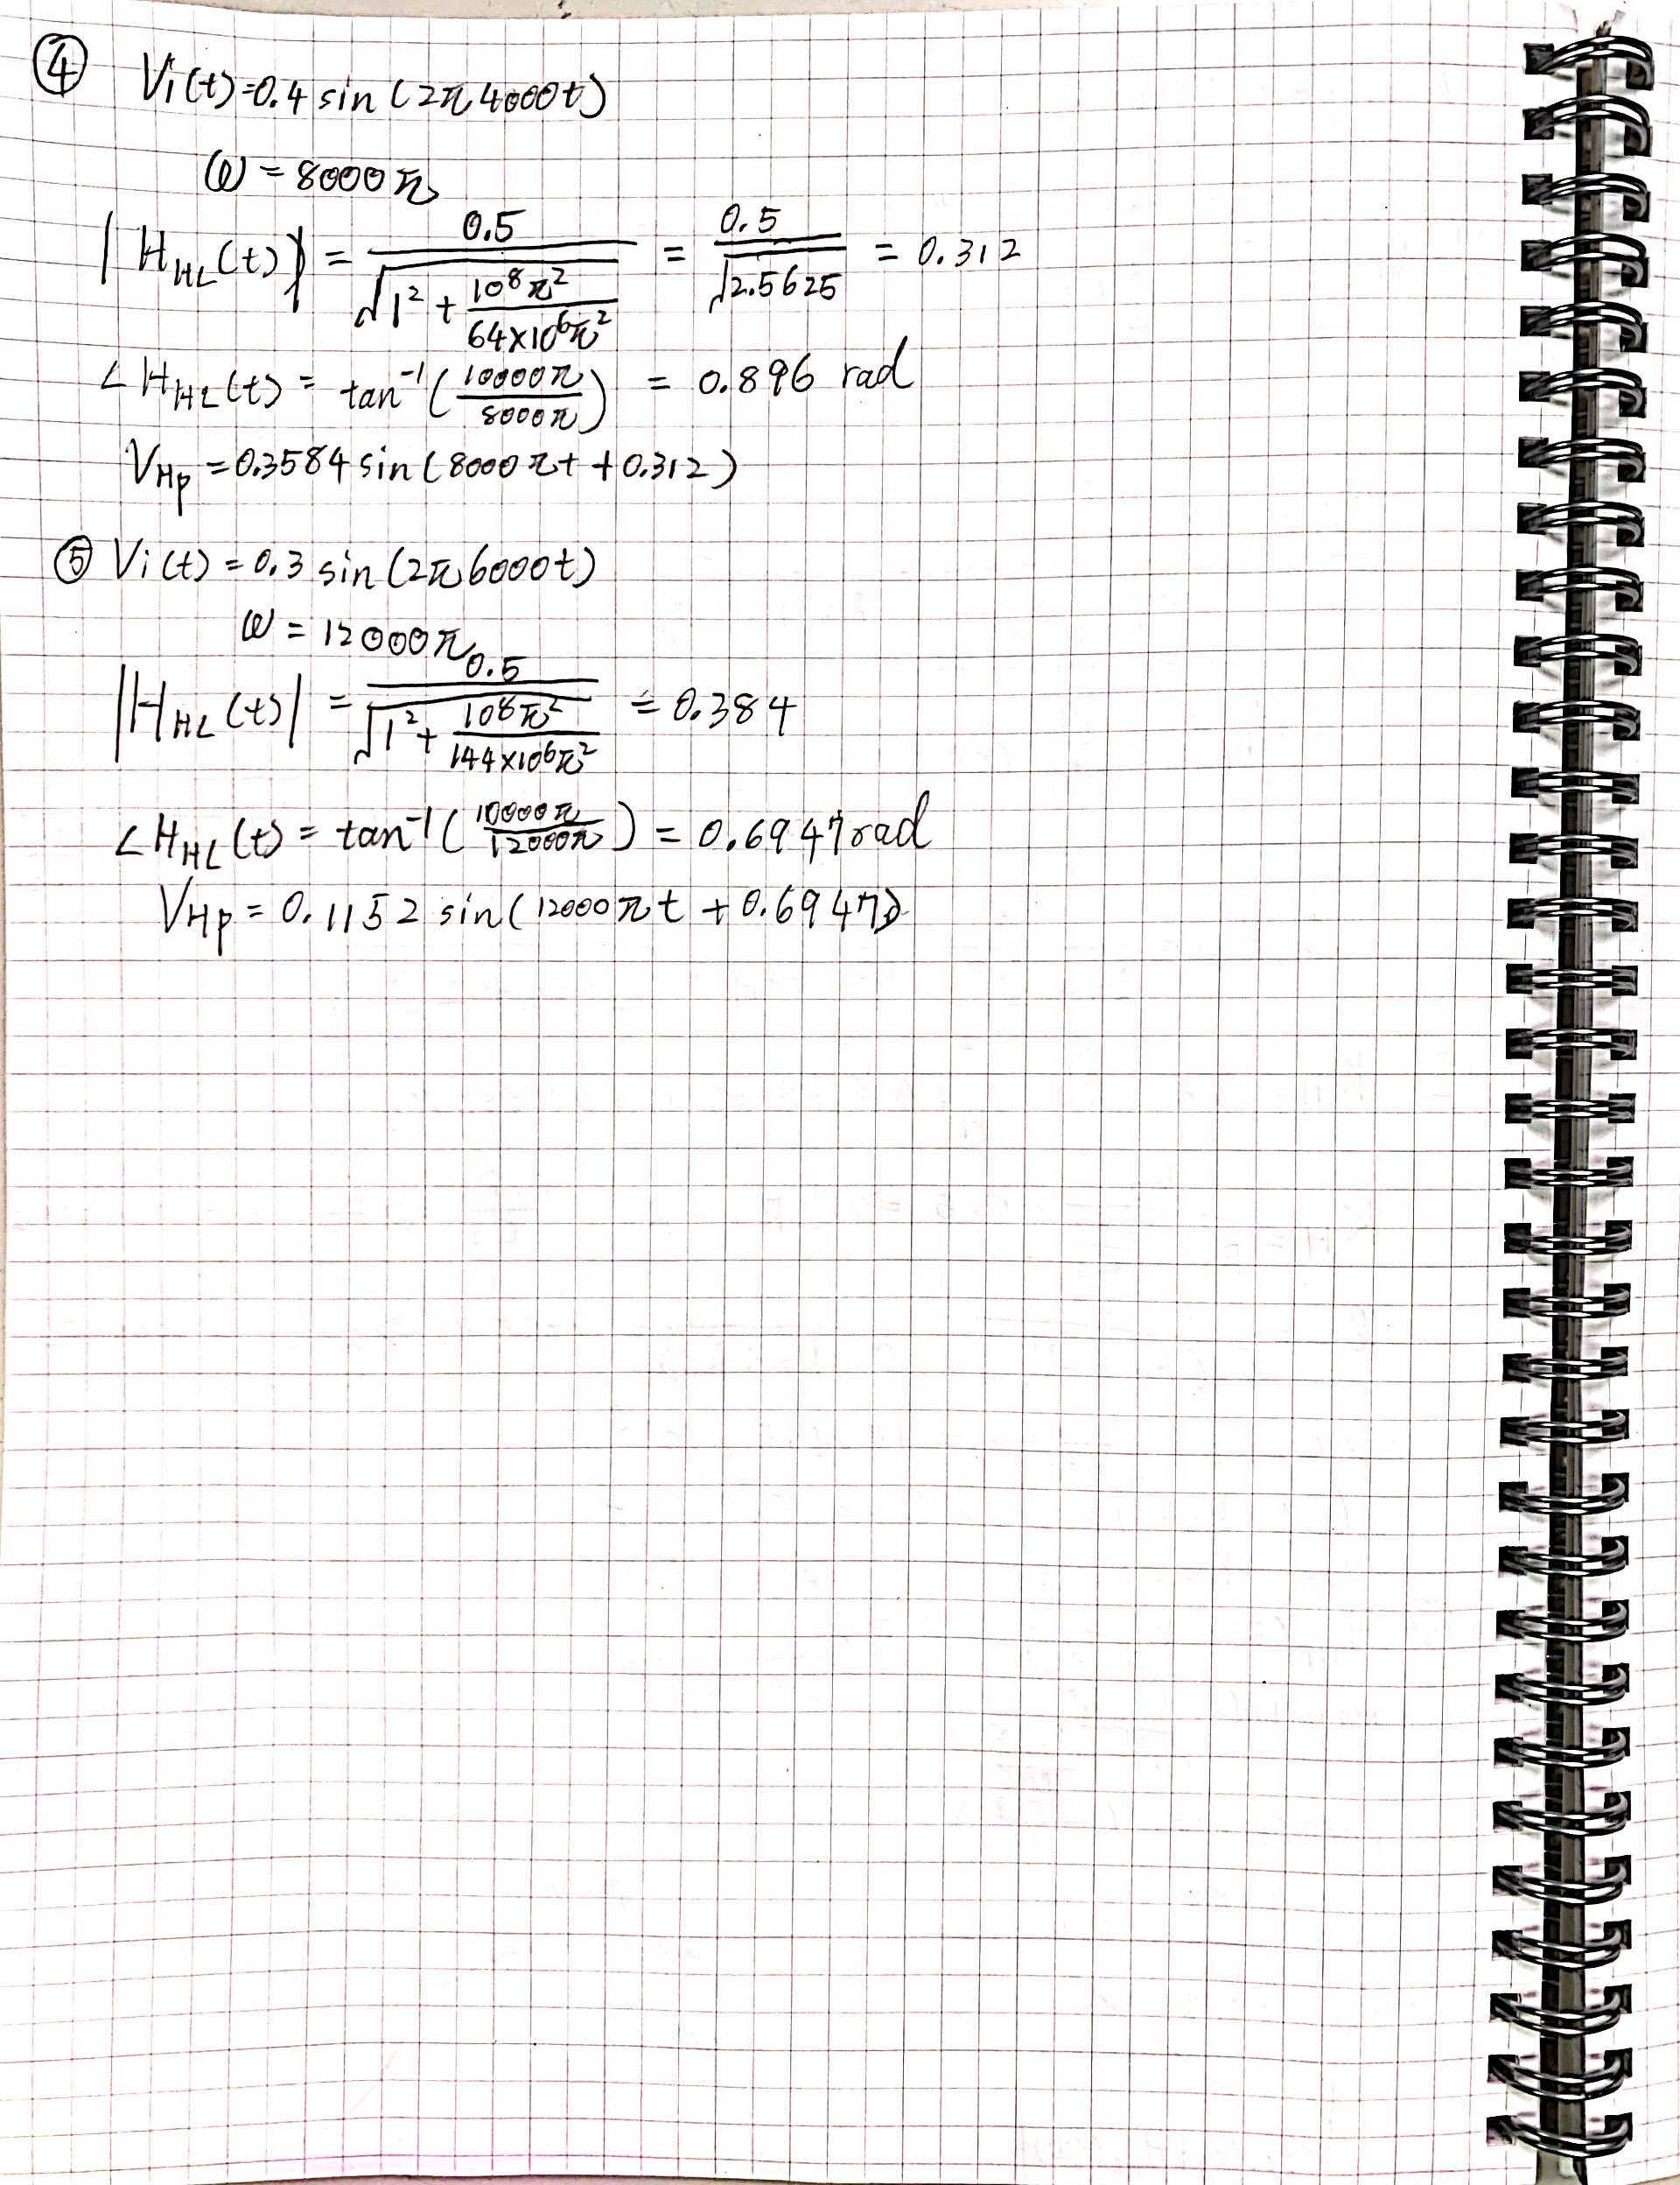

Schematic:

*included both in calculation and simulation*

Simulation:

Lowpass filter:

1.

3 dB frequency: when dy is around 3, frequency is 5.0802k, and the passband gain is -9.1007 dB

Magnitude at 4kHz and 6kHz: -8.1691dB and -9.8945dB

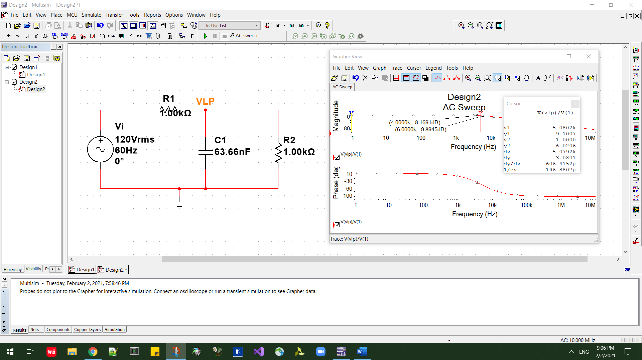

2.magnitude of input and output are 399.9426mV and 162.2096mV

Phrase difference: change in time is 2.3750ms – 2.2769ms = 0.0981ms

T = 1 / 4000 = 0.00025s

Phrase difference = 0.0000981s/0.00025s*2pi=2.4655rad

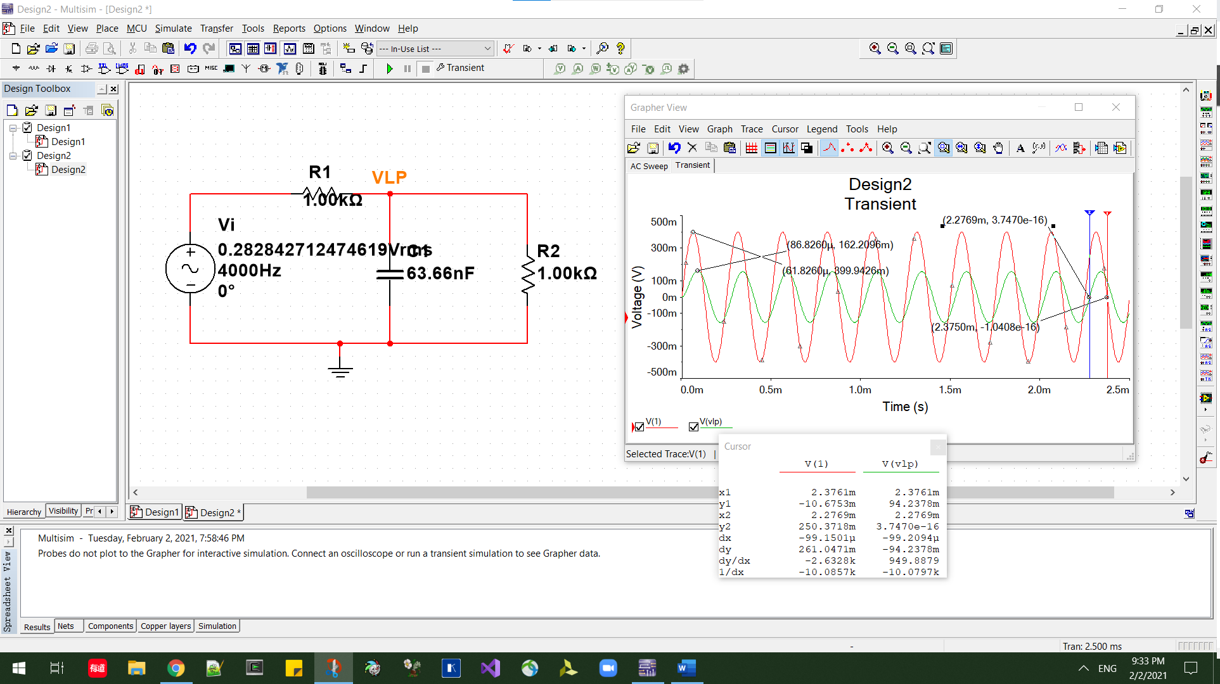

3. magnitude of input and output are 299.8579mV and 96.1093mV

Phrase difference: change in time is 1.75ms – 1.8566ms = -.1066ms

T = 1 / 6000 = 0.00016667s

Phrase difference = -0.0001066s/0.00016667s*2pi=-4.0187rad

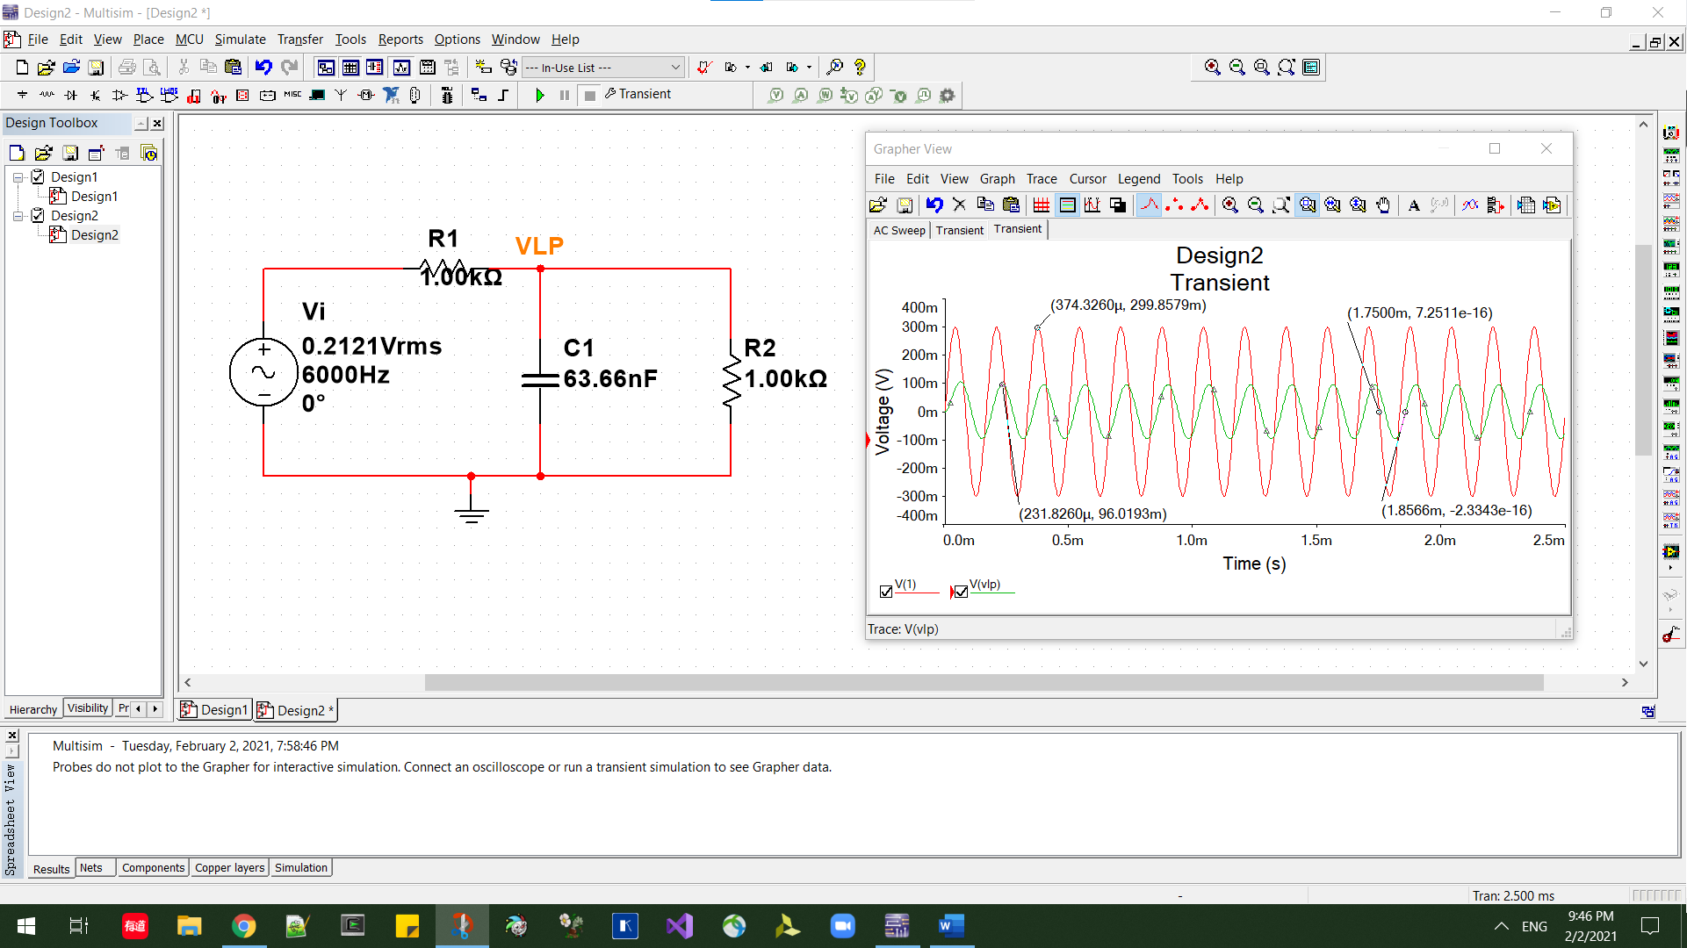

Highpass filter:

1.

3 dB frequency: when dB is around 3, frequency is 4.9694k, and the passband gain is -9.0580 dB

Magnitude at 4kHz and 6kHz: -10.1076dB and -8.3112dB

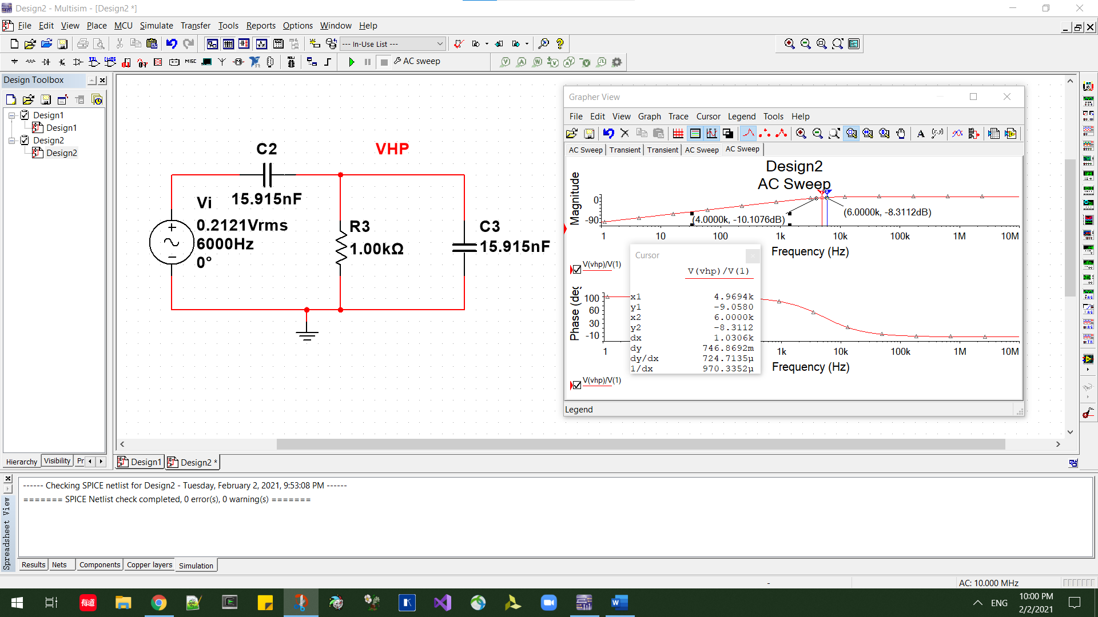

2.magnitude of input and output are 399.8777mV and 124.8736mV

Phrase difference: change in time is 2.1250ms – 2.0894ms = 0.0356ms

T = 1 / 4000 = 0.00025s

Phrase difference = 0.0000356s/0.00025s*2pi=0.8947rad

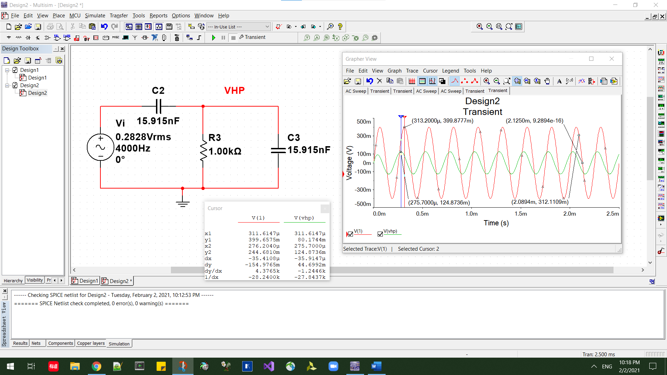

3. magnitude of input and output are 299.9498mV and 115.1906mV

Phrase difference: change in time is 1.3333ms – 1.3149ms = 0.0184ms

T = 1 / 6000 = 0.00016667s

Phrase difference = -0.0000184s/0.00016667s*2pi=-0.6936rad

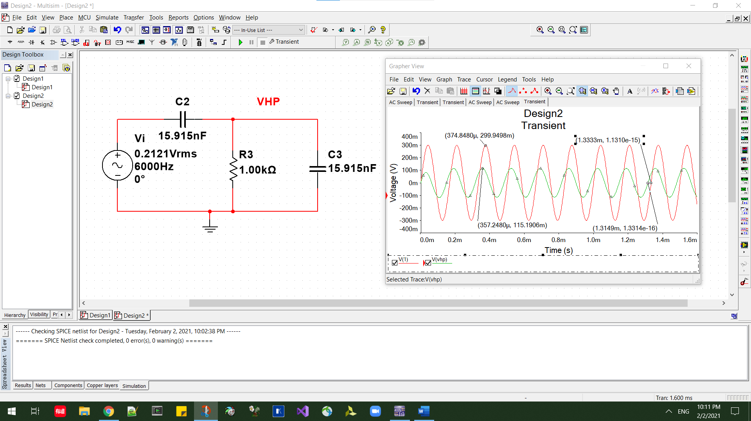

Measurements:

*since I am not doing in person lab, measurements will be same as simulations

Table, analysis, and conclusion:

For Vi(t)=0.4sin(2pi4000t):

|  |  |  |
| --- | --- | --- |
| Output voltages | calculated | simulated |
| lowpass | 0.156sin(2pi4000t-0.675) | 0.162(2pi4000t+2.4655) |
| highpass | 0.3584sin(2pi4000t+0.312) | 0.1248736sin(2pi4000t+0.8947) |

For Vi(t)=0.3sin(2pi6000t):

|  |  |  |
| --- | --- | --- |
| Output voltages | calculated | simulated |
| lowpass | 0.96sin(2pi6000t-0.876) | 0.961093sin(2pi6000t-4.018) |
| highpass | 0.1125sin(2pi6000t+0.6947) | 0.1151906sin(2pi6000t-0.6936) |

Note that phrase might be differed by one or two pi, which is 3.1415… or 6.2831…

From the comparison, we can see that the magnitude and phrase of highpass of Vi(t)=0.4sin(2pi4000t) exists significant difference between calculated and simulated result, the rest of the result matches well with the calculated result. I believe this difference was caused by the choice of cursor.